ASSIGNMENT 3

Q1. Connect one PC with another PC.
1. Connect Two PCs
- Drag 2 PCs into workspace
- Click Connections (⚡ icon)
- Select Copper Cross-Over cable
- Connect:
  - PC1 → FastEthernet0
  - PC2 → FastEthernet0
2. Assign IP Address
On each PC:
- Go to Desktop → IP Configuration
Fill:
PC1:
- IP Address: 192.168.1.1
- Subnet Mask: 255.255.255.0
PC2:
- IP Address: 192.168.1.2
- Subnet Mask: 255.255.255.0

3. Test Connection
From PC1:
ping 192.168.1.2
From PC2:
ping 192.168.1.1

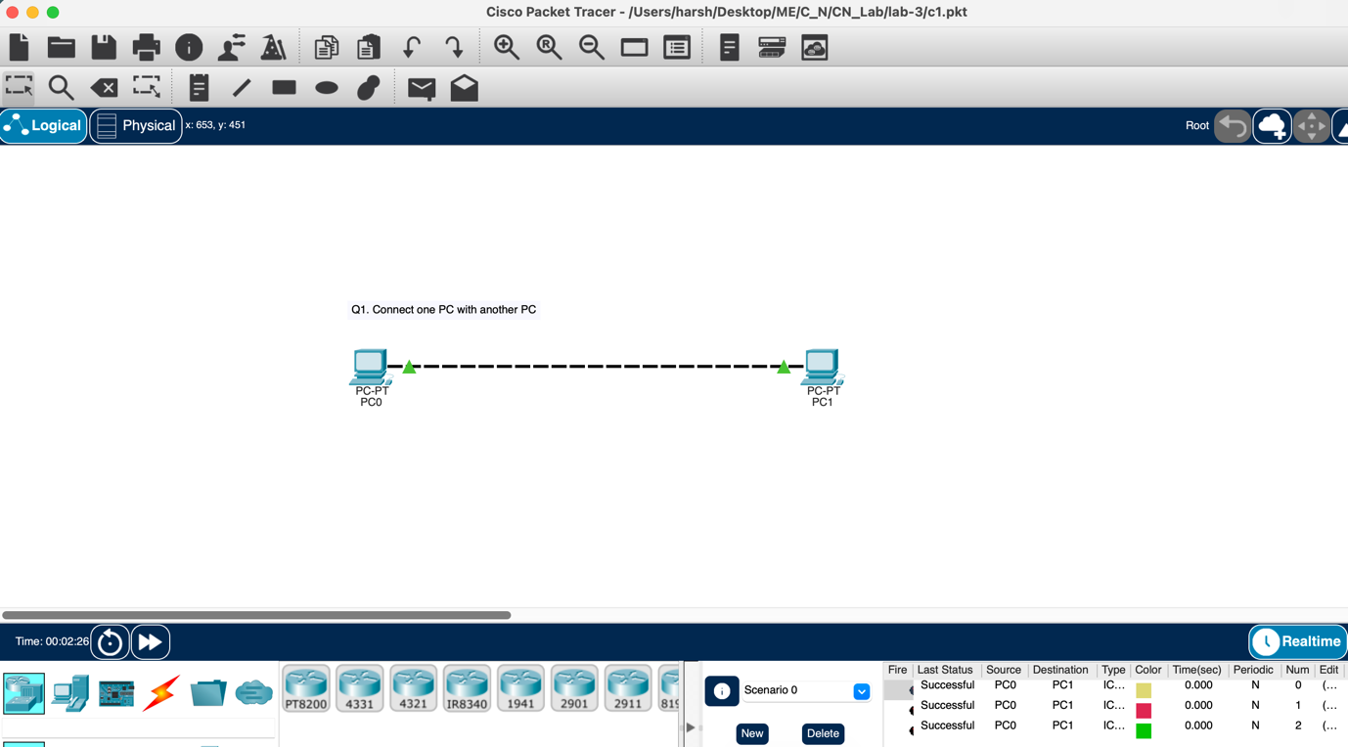

Q2. Connect a PC with Router Ethernet port.
1. Physical Connection
- Use Copper Straight-Through cable
- Connect:
  - PC → FastEthernet0
  - Router → FastEthernet0/0 (or GigabitEthernet0/0)

2. Configure Router
Go to Router CLI:
enable
configure terminal
interface fastethernet 0/0
ip address 192.168.1.1 255.255.255.0
no shutdown
exit

3. Configure PC
Method (GUI):
Desktop → IP Configuration
- IP Address: 192.168.1.2
- Subnet Mask: 255.255.255.0
- Default Gateway: 192.168.1.1

4. Test Connection
From PC Command Prompt:
ping 192.168.1.1

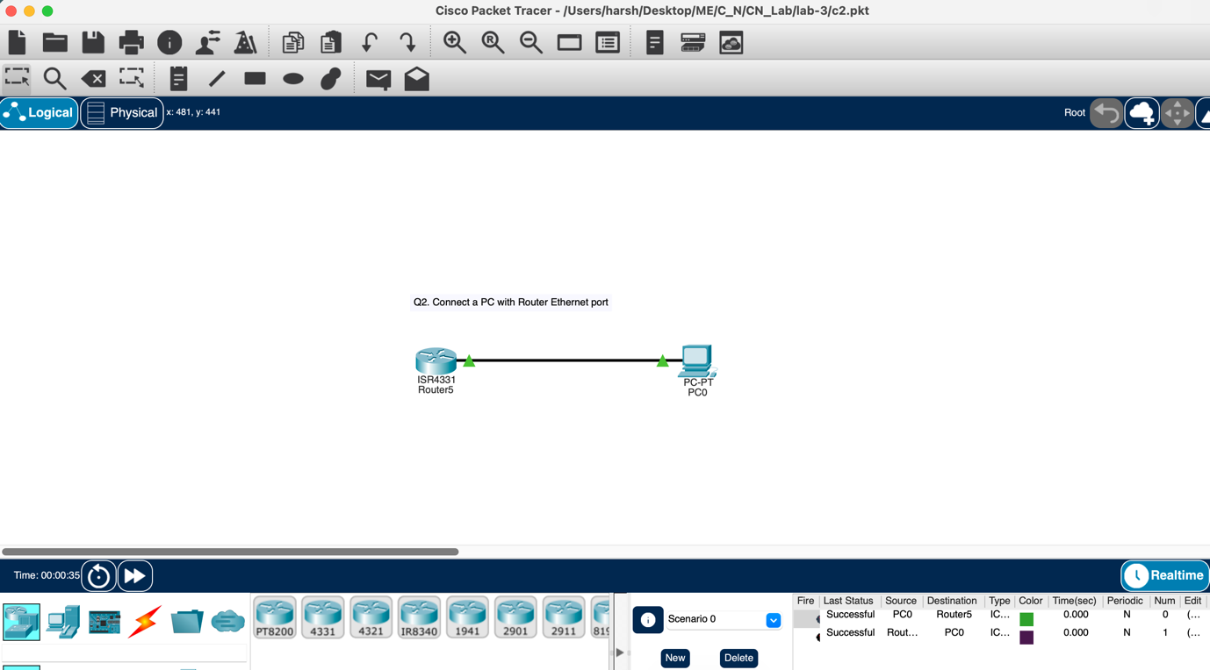

Q3. Create a network of 2 PCs.
1. Add Devices
- Drag 2 PCs into workspace
2. Connect PCs
- Go to Connections (⚡)
- Choose Copper Cross-Over cable
- Connect:
  - PC1 → FastEthernet0
  - PC2 → FastEthernet0
3. Assign IP Addresses
On PC1 (Command Prompt):
ip 192.168.1.1 255.255.255.0
On PC2 (Command Prompt):
ip 192.168.1.2 255.255.255.0
4. Test Connectivity
From PC1:
ping 192.168.1.2
From PC2:
ping 192.168.1.1
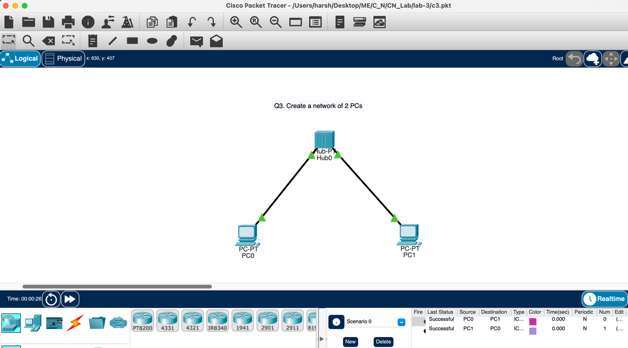

Q4. Connect 2 PCs with a Switch.
1. Physical Connection
- Add:
  - 2 PCs
  - 1 Switch (e.g., 2960)
- Use Copper Straight-Through cable
Connect:
- PC1 → Switch (FastEthernet0/1)
- PC2 → Switch (FastEthernet0/2)

2. Assign IP Address (on PCs)

Using Command Prompt (inside PC)

On PC1:
ip 192.168.1.1 255.255.255.0

On PC2:
ip 192.168.1.2 255.255.255.0

3. Switch Configuration (Optional)

By default, switch works without config, but if required:
enable
configure terminal
interface range fastethernet 0/1 - 2
no shutdown
exit

4. Test Connection
From PC1:
ping 192.168.1.2
From PC2:
ping 192.168.1.1
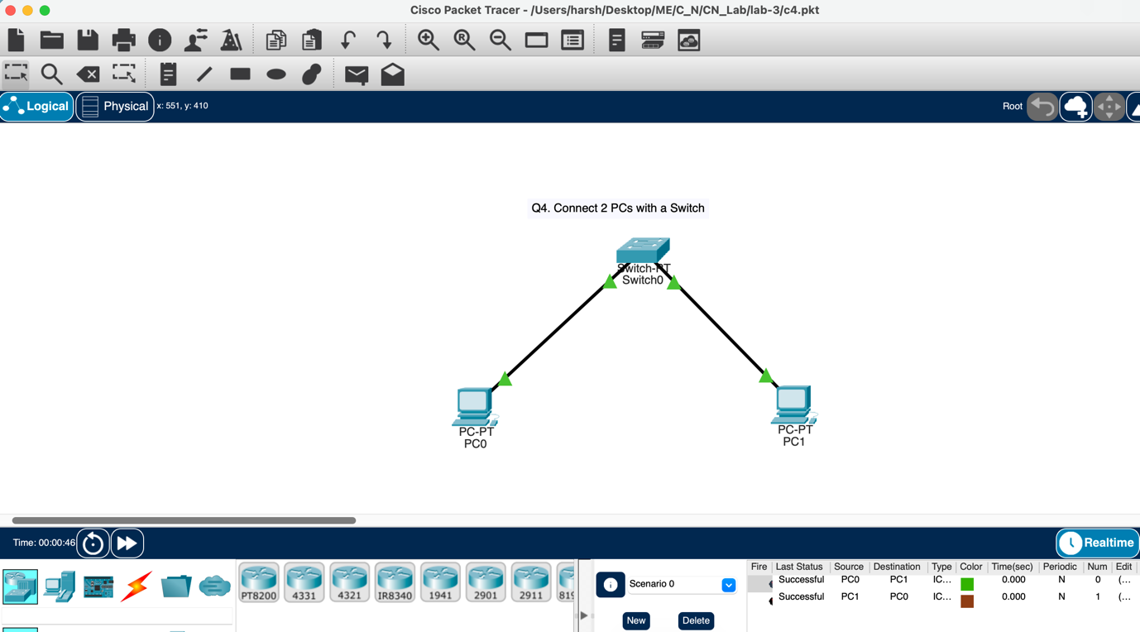

Q5. Create BUS topologies
a)
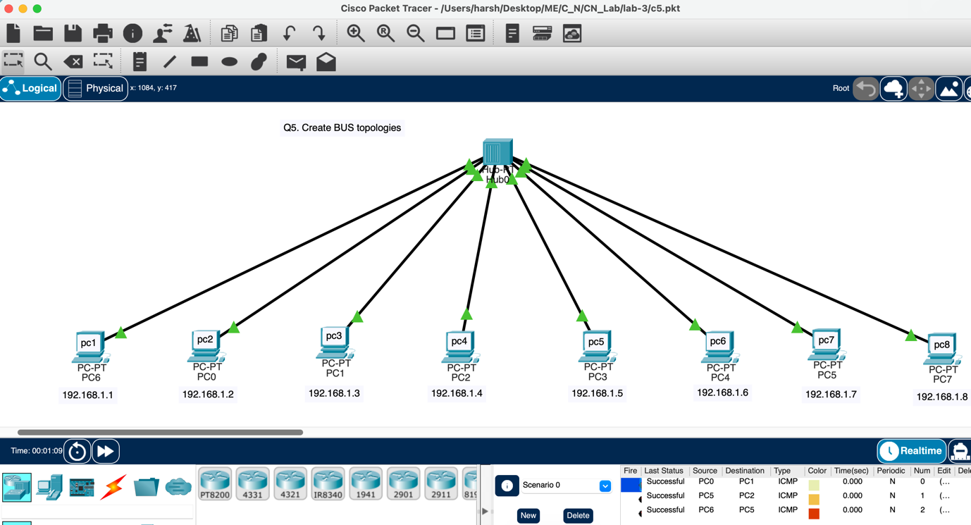

b)
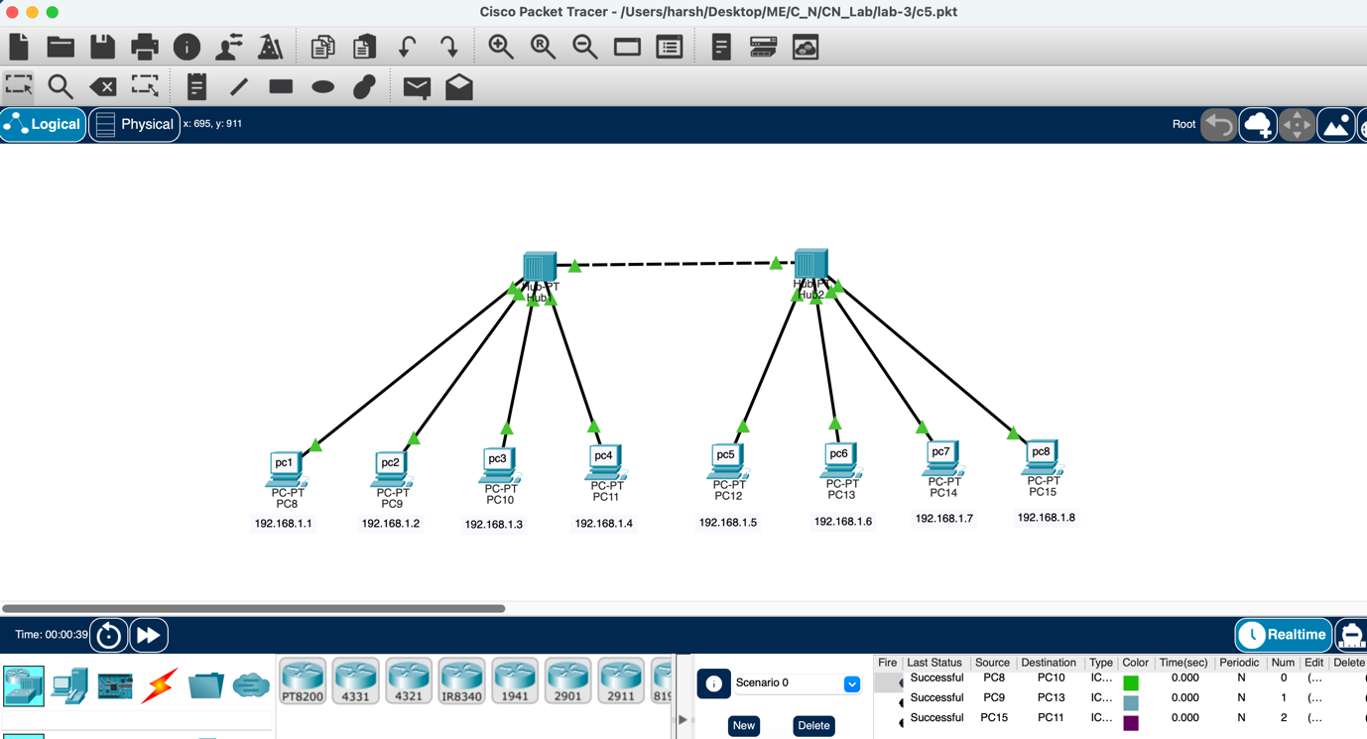

Q6. Create the following Ring Topology.
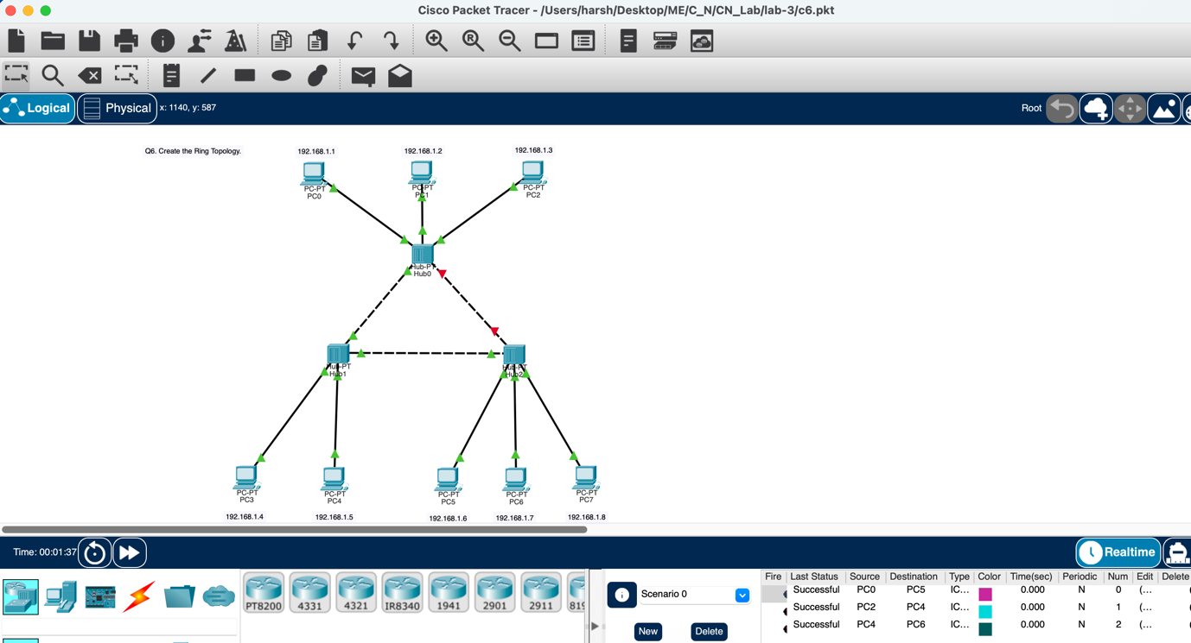

Q7. Create the following Ring Topology
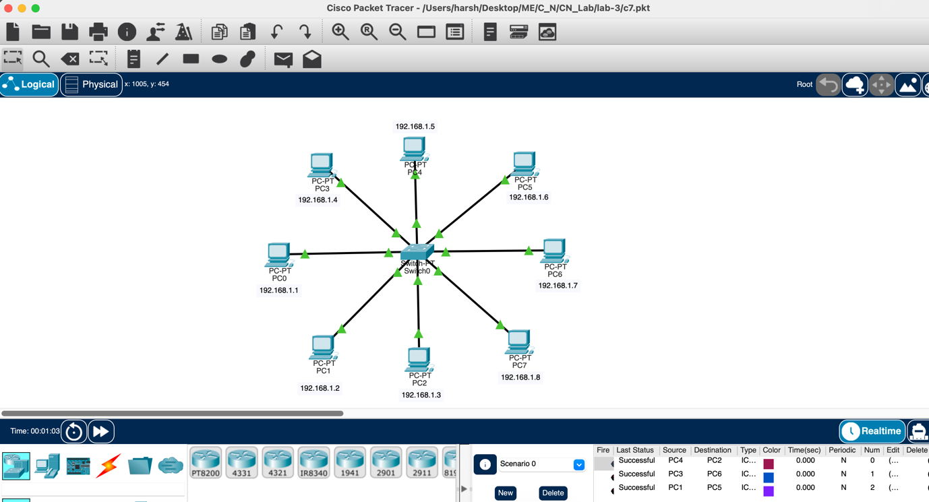

Q8. Create the following Tree Topology.

